**HOUSE TAX BILLING SYSTEM**

**AIM:**

To implement an application which deals with maintaining house tax managing activities like generating a house tax bill, customer personal records and other administrative activities.

**PROBLEM ANALYSIS AND PROJECT PLAN:**

* Tax is any form charge levied on a person or an institution by a governing body or its equivalent such that defaulted payment is punishable by law.
* The imposition of taxes is as old as civilization itself cutting across religion, race and continental borders.
* Prompt tax payment and reduced tax evasion is always a primary objective of the government in most civilizations that exist today.
* Some of the challenges governmental bodies have to overcome in order to encourage the prompt payment of taxes and effectively reduce evasion includes, developing convenient payment methods and having proper records keeping systems.

**PROBLEM STATEMENT:**

* The house tax billing system is meant for maintaining information of customers.
* It calculates the house tax of the customer based on the area.
* In this house tax of customer is calculated by maintaining different files such as customer information file,bills files,tracking bills to know the status of the bill.All these files are integrated.
* These files are stored in record where all informations can be searched using its bill number.
* In this we clearly identify the basic tax structure and provides a methodology for the customers to easily pay the house tax bills through online.

**INTRODUCTION:**

* Tax is a charge imposed by a government on persons, entities or property, administered to generate revenue for that government.
* Tax is a common source of income generation for financing government activities. Individuals and organizations are expected to fulfill their obligations on tax payment as required by law to give the government the financial power, amongst other purposes of taxation.
* Effective taxation therefore becomes important as it is a source of required financial power for a government to rule its territory.

**PURPOSE:**

* The main purpose of a billing system is to make life easier for a customer.
* It is a basic customer care tool which also ensures that the company obtains payments in time.
* Before setting up a billing account, the personal information of customers is analysed.
* The customers’ credit worthiness is the main information which an agency will pay attention to. After all this information is verified, the customers’ billing systems are established.

**SCOPE:**

* The main scope of a billing system is to create a gateway to implement online payments.

**USER CHARACTERISTICS:**

**USE CASE DIAGRAM:**

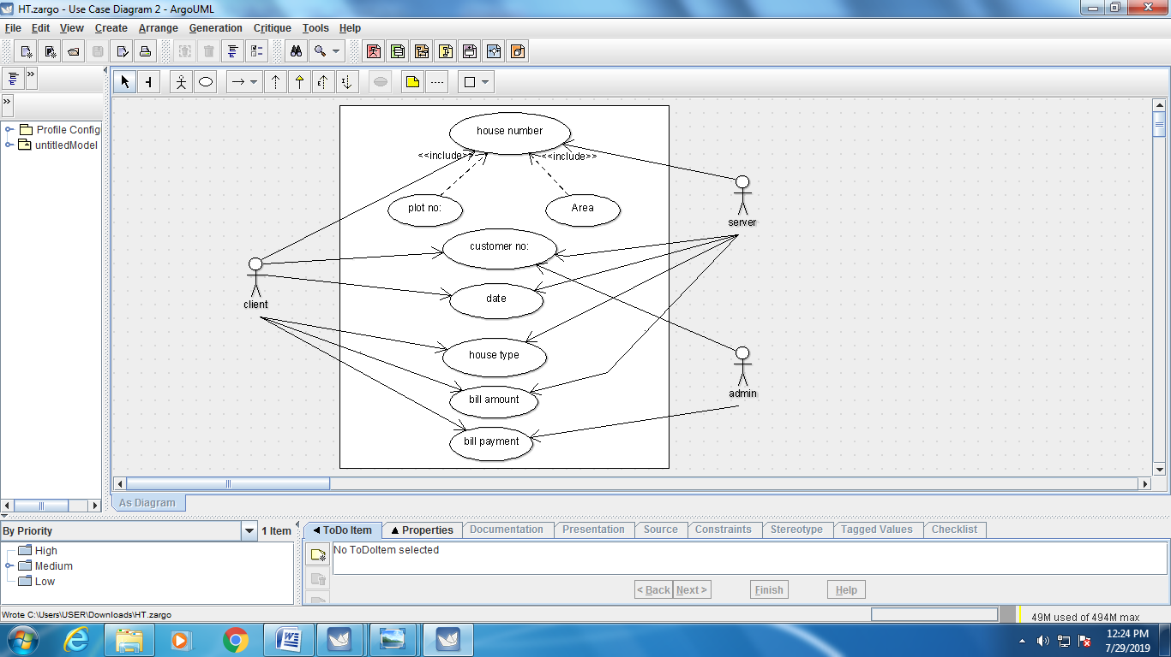

**CLASS DIAGRAM:**

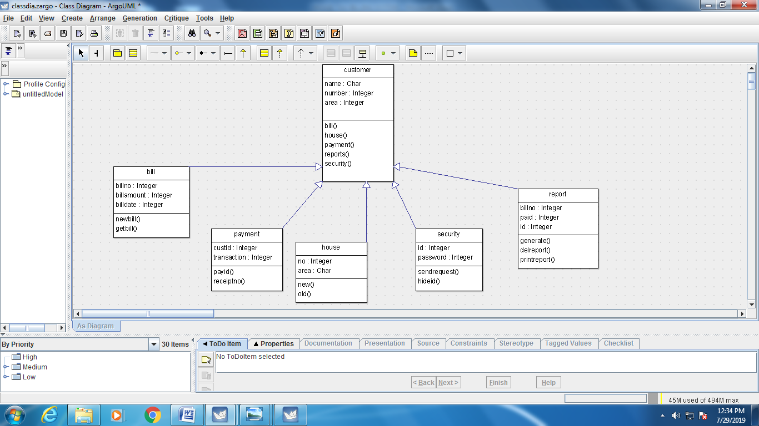

**SEQUENCE DIAGRAM:**

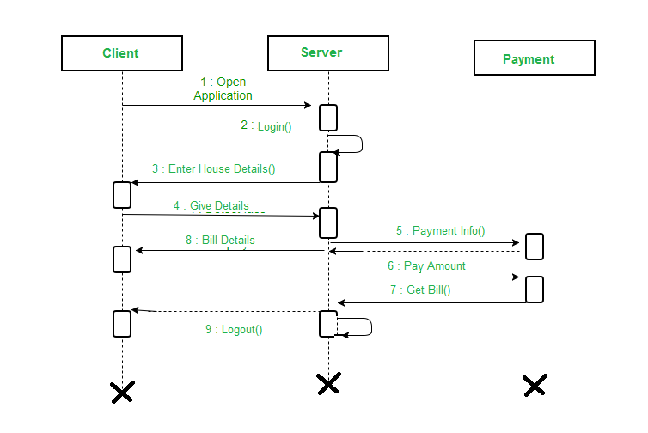

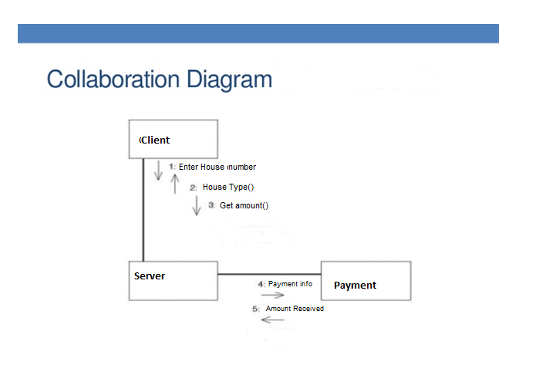

**STATE CHART DIAGRAM:**

